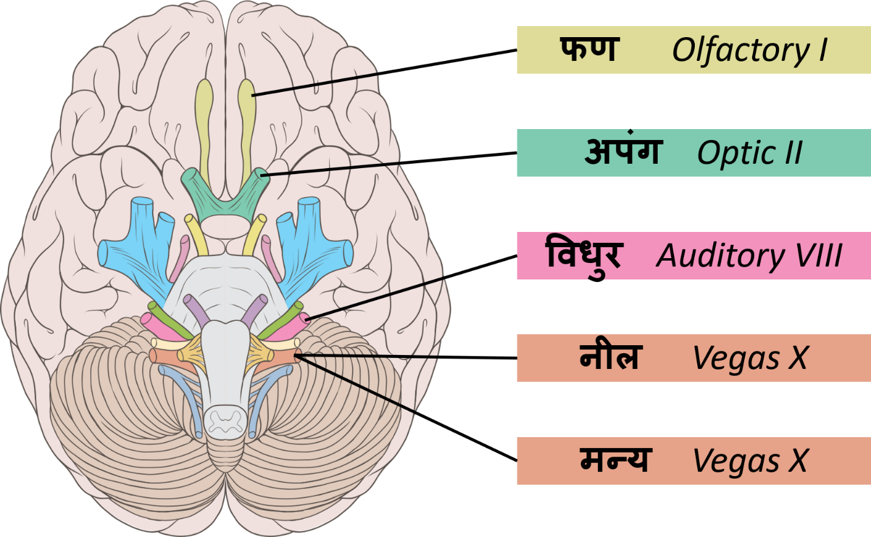

नील Vegas X

मन्य Vegas X

विधुर Auditory VIII

फण Olfactory I

अपंग Optic I

Sushruta Samhita (3.6.27)

अत ऊर्ध्वमूर्ध्वजत्रुगतानि व्याख्यास्यामः- तत्र कण्ठनाडीमुभयतश्चतस्रो धमन्यो द्वे **नीले** द्वे च **मन्ये** व्यत्यासेन , तत्र मूकता स्वरवैकृतमरसग्राहिता च; ग्रीवायामुभयतश्चतस्रः सिरा मातृकाः, तत्र सद्योमरणं; शिरोग्रीवयोः सन्धाने कृकाटिके, तत्र चलमूर्धता; कर्णपृष्ठतोऽधःसंश्रिते **विधुरे**, तत्र बाधिर्यं; घ्राणमार्गमुभयतः स्रोतोमार्गप्रतिबद्धे अभ्यन्तरतः **फणे**, तत्र गन्धाज्ञानं; भ्रूपुच्छान्तयोरधोऽक्ष्णोर्बाह्यतो**ऽपाङ्गौ**, तत्रान्ध्यं दृष्टयुपघातो वा; भ्रुवोरुपरि निम्नयोरावर्तौ नाम, तत्राप्यान्ध्यं दृष्टयुपघातो वा; भ्रुवोरन्तयोरुपरि कर्णललाटयोर्मध्ये शङ्खौ, तत्र सद्योमरणं; शङ्खयोरुपरि केशान्त उत्क्षेपौ, तत्र सशल्यो जीवेत् पाकात् पतितशल्यो वा नोद्धृतशल्यः; भ्रुवोर्मध्ये स्थपनी, तत्रोत्क्षेपवत्; पञ्च सन्धयः शिरसि विभक्ताः सीमन्ता नाम, तत्रोन्मादभयचित्तनाशैर्मरणं; घ्राणश्रोत्राक्षिजिह्वासन्तर्पणीनां सिराणां मध्ये सिरासन्निपातः शृङ्गाटकानि , तानि चत्वारि मर्माणि, तत्रापि सद्योमरणं ; मस्तकाभ्यन्तरोपरिष्ठात् सिरासन्धिसन्निपातो रोमावर्तोऽधिपतिः, तत्रापि सद्य एव | एवमेतानि सप्तत्रिंशदूर्ध्वजत्रुगतानि मर्माणि व्याख्यातानि ||२७||

The Jatrugata-Marmas: Now we shall describe the Marmas which are situated in the regions above the clavicles (Urddhva-Jatru). There are four Dhamani (arteries) about the two sides of the Kantha-Nadi (wind-pipe). Two of them are known as **Nilá**, and the other two as **Manyá**. One Nilá and one Manyá are situated on either side of the larynx, (i.e. anteri or and posterior side of the larynx). An injury to any of them produces dumbness, and change of voice (hoarseness), and also the loss of the faculty of taste.

An injury to any of the eight Siras (arteries), four being on each side of the neck (Griva), and known as **Sirá-Mátrika-Marmas** ends fatally within the day.

An injury to any of the two Marmas lying at the junction of the head and neck (Griva) and known as **Krikátika** (transverse process of the arch of the atlas) results in a free movement of the head.

A hurt to any of the Marmas attached to the lower end of an ear (posterior extrinsic ligament) and known as the **Vidhura** Marma results in the loss of hearing.

An injury to the **Phana-Marmas** attached to the interior channels of both the nostrils, results in the loss of the faculty of smell.

An injury to the **Apánga-Marmas** (Anastomosis of the infra-orbital artery) situated below the tips of the eye-brows and about the external corners of the eyes, brings on blindness or defective vision.

An injury to the **Avarta-Marmas** situated above and below the eye-brows, brings on blindness and impaired vision.

An injury to the **Sankha-Marmas** (meeting or suture of the temporal, frontal and sphenoid bones — Pterion), situated over the tips of the eye-brows and between the ears and the forehead, results in death within the day.

The Marmas situated over the two temples (Sankha) and at the border of the hair (sculp) are called **Utkshepa-Marma** (meeting of the posterior and anterior temporal arteries). An extraction of a shaft (Salya) or of any extraneous pointed thing lodged into these Marmas, results in the death of the patient, who, on the contrary, lives as long as the shaft is allowed to remain inside or if the shaft comes out itself (after putrefaction).